Housing Support Referral Form

Your name: |  | Todays date:

If someone is helping you fill out the form, please give their details below

Name:

Organisation:

Relationship to applicant:

Address:

Telephone:

Email:

If the form is being filled in on behalf of someone, ‘you’ refers to the person who needs housing or support.

Questions

We want to find out about where you would like to live.

To do this, we need to ask you questions.

About you

National insurance number: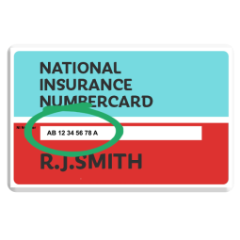 |  | Date of birth:
Gender: |  | Telephone:
Address:

Your current situation

 | Please describe your current living situation e.g. what type of accommodation you live in, who you live with, is it home owned, rented, homeless, due to be evicted etc.
 | Do you have any debts or are in arrears? | Yes / No
 | If yes, please give details including the amounts and any legal action

What you are looking for

 | Please describe where you would like to live e.g. a quiet place, near shops, cafes, social clubs etc.
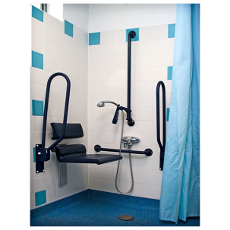 |  | Please describe any accessibility factors that need to be taken into account e.g. can you manage stairs, do you require any assistance aids etc.
 |  | Please describe how you get on with other people e.g. do you like making friends, prefer to be by yourself etc.

Support

Is funding in place? | Yes / No | If no, please give details of when funding is likely to be in place:
Support you are eligible for:
Number of hours: |  | Sleep in or on-call provided: | Sleep in / On-call / None
Details of the funding authority:
Name:  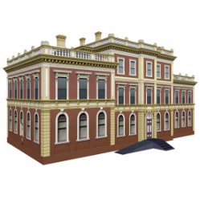 |  | Address:
Contact name: |  | Contact telephone:
Contact email:

Please list any benefits you receive e.g. ESA, PIP etc.

Please enter any other information you feel relevant to your application

Documents to send

Along with your referral, the following documents are also required:

An up to date FACE assessment
Community team assessments or reports such as OT, SALT, psychology, psychiatry etc.
Individual budget (if LA funded) or similar funding agreement (if NHS funded)
Support plan and risk assessment (if available)

The referral should be emailed to Housing.manager@aldingbourne.org or posted to the Housing Manager at 73 Aldwick Road, Bognor Regis, Sussex, PO21 2NW.

Signature

Your signature:

What happens next

1 |  | The Housing Manager will acknowledge your application
2 |  | A housing panel will meet once a month and review the referral.  They will decide if you are someone who the Trust could potentially house.  They will then look at available accommodation (if any) and see if any referrals are suitable for that accommodation and who is the highest priority.
3 |  | The Housing Manager will contact you to let you know the outcome of the housing panel meeting.  If the Trust is unable to offer accommodation at the current time, a member of the Housing team will contact you periodically to see if you have found alternative accommodation.  You will be kept on the housing list for 18 months.
4 |  | If the Trust is able to offer you accommodation, all the forms requested above must be complete.  In addition, you will be asked for documents to prove that you have a right to rent. The Trust will help you with this.

